|  |  |  |  |
| --- | --- | --- | --- |
| \\lyng-dc1\StaffShared\Learning Bugs Animals ALL subjects\characters bugs animals\Cyril the Snail - History.jpeg**Lyng Primary School Knowledge Organiser** | | | |
| **History Topic:** | **Was the Roman Empire successful in changing the world?** | Year 3  *Battles, Beliefs and Buildings* | Summer Term |

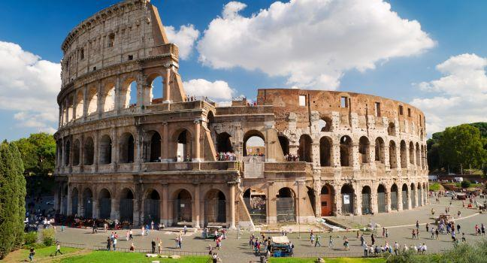

Ancient Rome was a powerful civilization that ruled much of Europe for nearly 1000 years. Their culture spread throughout Europe and as a result, it still has an impact in the Western world today. The basis for much of Western culture comes from Ancient Rome, especially in areas such as government, engineering, architecture, language, and literature.

|  |  |
| --- | --- |
| **What Step On and Goldilocks words will I use?** | |
| **Spelling** | **Definition** |
| arena | An arena is a place where sports, entertainments, and other public events take place. It has seats around it where people sit and watch. |
| auxiliaries | Auxiliary soldiers were recruited from non-Roman tribes. Their name means 'helpers', and they assisted the Roman legionary troops by providing extra manpower. |
| cavalry | The cavalry is the group of soldiers in an army who ride horses. |
| catapult |  |
| conquer |  |
| emperor | An emperor is a man who rules an empire. |
| empire | An empire is a number of individual nations that are all controlled by the government or ruler of one particular country. |
| gladiator | In the time of the Roman Empire, a gladiator was a man who had to fight against other men or wild animals in order to entertain an audience. |
| government | The government of a country is the group of people who are responsible for governing it. |
| legionary | A soldier who was a Roman citizen younger than 45. |
| legions | A legion is a large group of soldiers who form one section of an army. |
| warrior |  |

|  |  |
| --- | --- |
| **When? (Timeline of key events)** | |
| 753 BC | The building of Rome begins. |
| 510 BC | Rome becomes a Republic and officials are elected. |
| 202 BC | Rome conquers territories outside Italy. |
| 130 BC | Rome conquers Greece and Spain. |
| 55 BC | Julius Caesar first invades Britain but is forced to return home. |
| 43 AD | The Roman army lands in England. |
| 61 AD | Boudicca rebels against the Romans. |
| 79 AD | Eruption of Mount Vesuvius. |
| 122 AD | The Building of Hadrian’s wall begins. |
| 200 AD | Rome is attacked by Barbarians. |
| 410 AD | Roman rule in Britain ends. |
| 455 AD | The Roman Empire collapses. |

**Hook**

Create a shield ready for our recreation of Boudicca’s revolt.

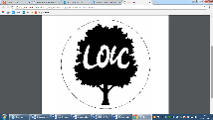

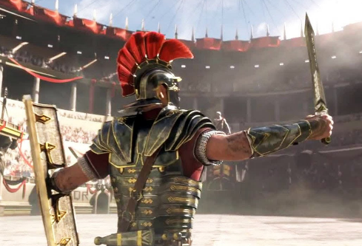

“Great empires are not maintained by timidity.” ― Tacitus.

**Great Quotes**

**Focus Text**

**Our Storytelling Approach to enhance engagement**

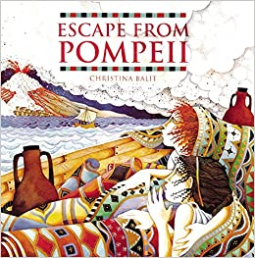

|  |  |  |
| --- | --- | --- |
| **People:**  Romans | **Place:**  Pompeii 79AD | **Problem:**  Volcanic Eruption |

**Key Facts and Famous Figures**

en tribes who fought each other for more land and power.

**Roman Army**

The Roman army was well-equipped, well-organised and well-trained. Roman military tactics were effective and included the testudo and wedge formations. In the testudo formation, the soldiers formed a box with shields covering their sides and their heads, protecting them from the enemy’s weapons. If the enemy was too close, the soldier’s swords would be drawn suddenly to counterattack.

**Roman Gods and Goddesses**

In the earlier Roman times, the Roman people believed in many different gods and goddesses whom they believed controlled different aspects of their lives. They did not have a central belief system of their own as such, but rather borrowed gods, rituals and superstitions from a number of sources and adapted them to suit their own needs.

The Romans believed in good and bad omens and they performed many rituals in the hope of receiving good luck. Prayer and sacrifice was important and the Romans held festivals every month to honour the gods. They would worship their gods and goddesses at temples.

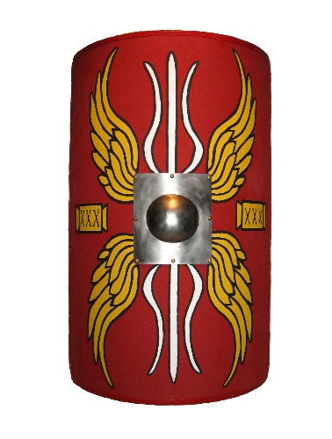

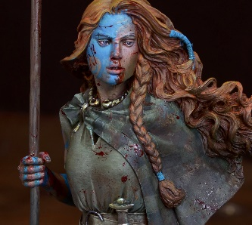

* How was the Roman army so successful? (Hook lesson using shields we have made in art).
* How was Rome founded?
* How similar were Ancient Greek and Roman soldiers?
* What was life like for a gladiator?
* Why did the Romans invade and settle in Britain?
* What impact did the Romans have on Britain?

**Enquiry Questions**

**Agreed Outcome**

Roman Shield

Timeline of all four historical time periods studied this year to demonstrate concurrence

|  |  |  |  |
| --- | --- | --- | --- |
| \\lyng-dc1\StaffShared\Learning Bugs Animals ALL subjects\characters bugs animals\Cyril the Snail - History.jpeg**Lyng Primary School Knowledge Quiz** | | | |
| **History Topic:** | **Was the Roman Empire successful in changing the world?** | Year 3  *Battles, Beliefs and Buildings* | Summer Term |

**Roman Empire Quiz**

|  |
| --- |
| 6) What is an empire? |
| Start: |
| End: |

|  |  |
| --- | --- |
| 7) Name a country that was part of the Roman Empire. | |
| Start: |
| End: |

|  |
| --- |
| 8) What happened in 79AD? |
| Start: |
| End: |

|  |  |  |
| --- | --- | --- |
| 9) The Romans invaded England. | **S** | **E** |
|  | True  False | True  False |

|  |  |  |
| --- | --- | --- |
| 1. Which of these is a roman legacy in Britain? | **S** | **E** |
| 1. Cake |  |  |
| 1. Roads |  |  |
| 1. Shields |  |  |

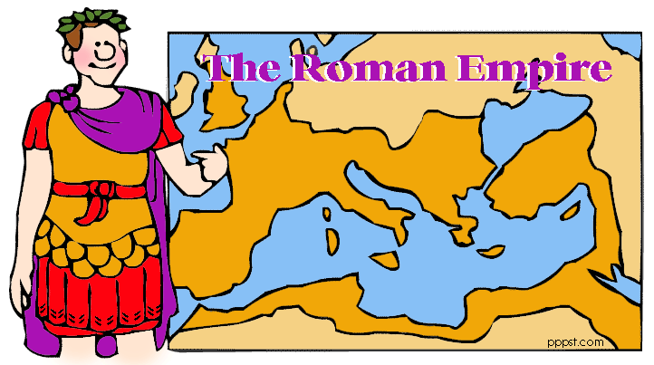

|  |  |  |
| --- | --- | --- |
| 1. Name a Roman Emperor. | **S** | **E** |
| Start: |  |  |
| End: |  |  |

|  |  |  |
| --- | --- | --- |
| 1. Which of the following was a Roman army formation? | **S** | **E** |
| 1. Block |  |  |
| 1. Chip |  |  |
| 1. Wedge |  |  |

**Start:**

**End:**

|  |  |  |
| --- | --- | --- |
| 1. Name a Roman God. | | |
| Start: |  |  |
| End: |  |  |

|  |  |  |
| --- | --- | --- |
| 1. What was a gladiator? | **S** | **E** |
| A man who had to fight against other men or animals in order to entertain. |  |  |
| A soldier who was a Roman citizen younger than 45. |  |  |
| A man who rules an empire. |  |  |